AMERICAN HERDING BREEDS ASSN.
AND

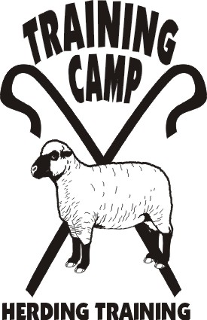

COURSES OFFERED:

HERDING RANCH TRIAL

HERDING ARENA TRIAL
&
JUNIOR HERDING DOG TEST

September 5, 2011

LOCATION:

Seaman Farm, Chisago, MN

OPEN TO ALL HERDING AND MIXED HERDING BREEDS
(DOGS AT LEAST 6 MONTHS OF AGE)

TRIAL CLASSES: HRD I, II, III – Sheep
HTAD I, II, III – Sheep
Course 4 w/gather & gate sort
TEST CLASSES: JHD – Sheep

ENTRY LIMITS: 12 RTD – 20 HTAD

MAIL ENTRIES TO:
JoAnna Yund
4047 Sheridan Ave. So.
Minneapolis, MN 55410

ENTRY FEES ALL CLASSES:
PRE-ENTRY (Due August 15, 2011) $30/run
Day-Of (livestock available) $40/run

TRIAL CHAIR: JoAnna Yund
JoAnnaY@aol.com

- Handlers Meeting for HRD will be at 7:30 a.m.
- Handlers Meeting for HTAD will be at 12:30 p.m.
- Competitors are responsible for cleaning up after their dogs. All dogs must be on leash when not competing.
- Competitors assume financial responsibility for medication and/or veterinary care and/or replacement value of stock for any injury caused by them or their dog(s).

DIRECTIONS TO SITE – available at www.trainingcampinc.com

